**Week 3 Assignment: Create a Lab Environment for your company**

Overview: Work as a group to create a lab environment containing a Domain Controller, a File Server, and a User Computer in your company. Divide the work however you like, but each group member must have a lab environment on their computer. Include a screenshot of each step. Crop your screenshots to show relevant information only. Uncropped screenshots will result in a 10% deduction from your mark.

Part 1:

1. Use VMWare workstation to create a VM using Windows Server 2019 to serve as your organisation’s first Domain Controller
   1. Remember to give your DC a name

* 1. Give your Administrator account a strong password (or you may bump into problems later) *(you do not need to include a screenshot for this step)*
  2. Use the “Add Roles or Features” Wizard to install the Active Directory Domain Services role to your server

* 1. Promote your server to a Domain Controller

After Active Directory installation we promoted it to the domain controller (first screenshot)

* 1. Assign the DC a static IP address

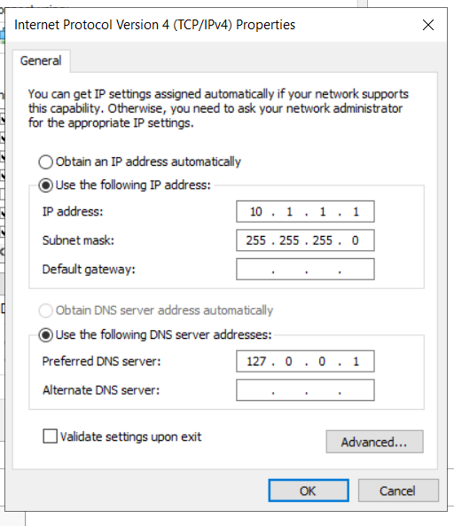

Part 2:

1. Create a user computer (Windows 10) and join it to the domain
   1. You will need to assign a workable IP to the user computer (it should be on the same subnet as the DC, and use the DC as the DNS address)

* 1. Give your user computer a logical name

* 1. Join it to the domain using a domain administrator account

Part 3:

1. Create a File and Print server (Windows Server 2019) for your company and join it to the domain
   1. You will need to assign a workable IP to the user computer (it should be on the same subnet as the DC, and use the DC as the DNS address)

* 1. Give your user computer a logical name

PFILPRTSRV001

(Physical\Virtual)(ServerType)SRV(number)

* 1. Join it to the domain using a domain administrator account

Part 4:

1. Create an OU for servers
   1. Move the File and Print server to this OU

1. Create an OU for user computers
   1. Move the User Computer to this OU

1. Create an OU for user accounts based on department or location (this is up to you and will depend on your organisation)

1. Create a user account for each of your group’s members and place them in the appropriate OU

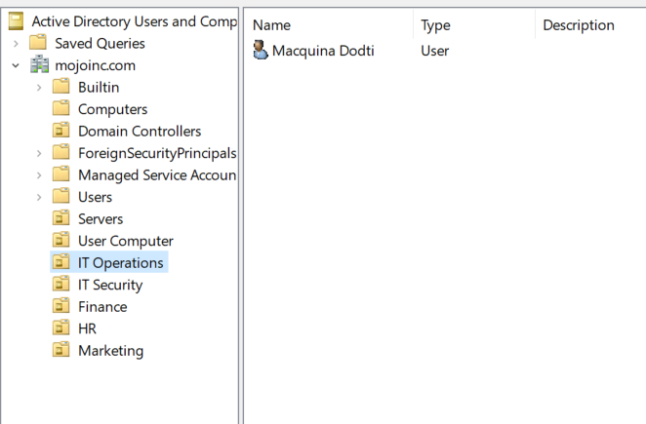

1. Create a security group that makes sense in your organisation
   1. Add the user accounts to the group

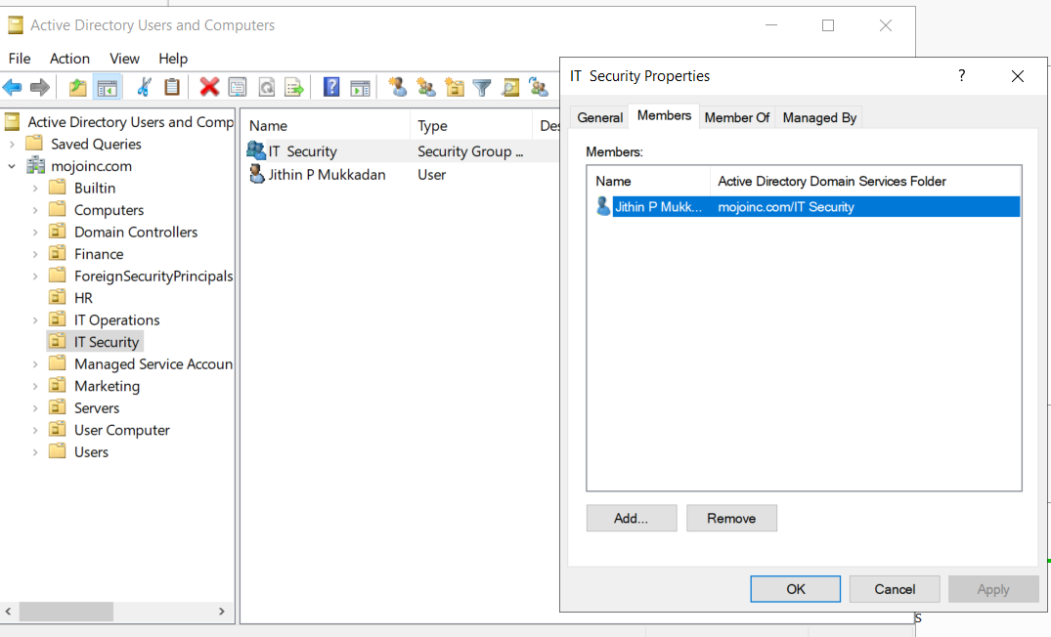

1. Create a distribution group that makes sense in your organisation
   1. Add the user accounts to the group

